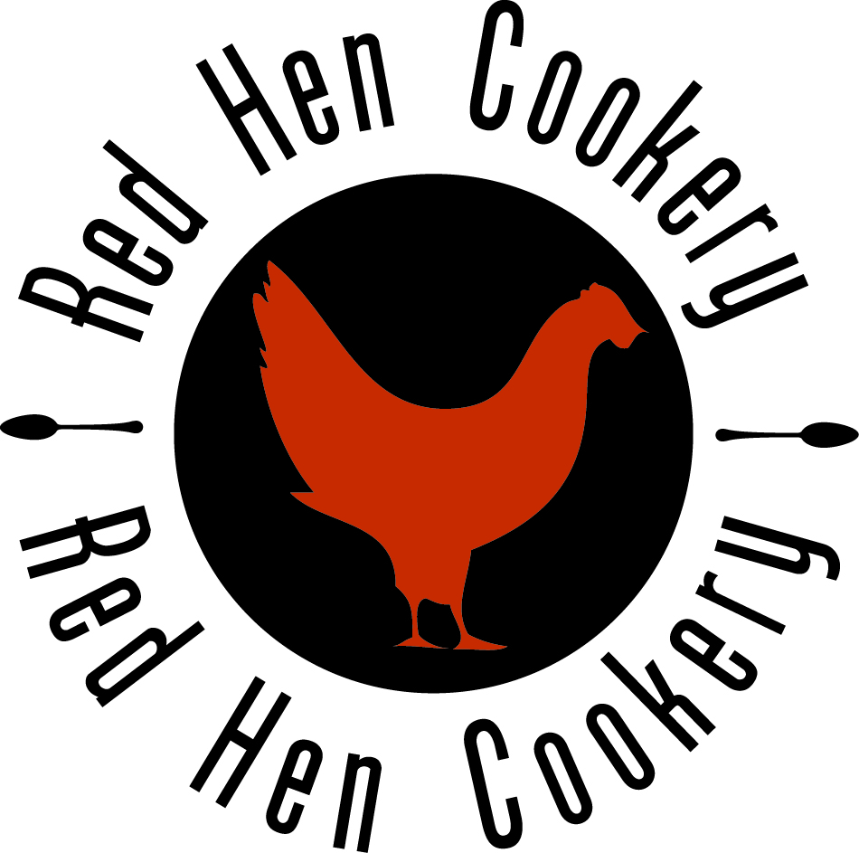
RED HEN COOKERY SCHOOL NURSERY Meals
 | WEEK ONE | WEEK TWO | WEEK THREE
MONDAY | Homemade Mild Vegetable Curry  Served with Rice  (Vegetable Bites)  Homemade Chocolate Cake | Chicken Breast Tenders (2)  Served with Potato Wedges, Peas, Carrots and Ketchup  Homemade Mixed Berry Sponge Cake | Fish Fingers (2)  (Fishless Fingers)  Served with Potato Wedges and Spaghetti Hoops  Homemade Banoffee Cake
TUESDAY | Homemade BBQ Cheese and Tomato Pizza on Wholemeal Base  Served with Spaghetti Hoops  Fromage Frais | Oven Baked Pork Sausages (2)  Served with Hash Browns and Baked Beans  (Vegetarian Sausages)  Neopolitan Ice Cream | Roast Chicken  (Quorn Roast)  Served with Roast Potatoes, Mixed Vegetables and Gravy  Fromage Frais
WEDNESDAY | Oven Baked Pork Sausages (2)  (Vegetarian Sausages)  Served with Mashed Potato, Peas and Gravy  Ice Cream | Homemade Mild Chicken Curry made with Chicken Breast and Vegetables  (Chicken Style Soya)  Served with Rice  Fromage Frais | Oven Baked Pork Sausages (2)  (Vegetarian Sausages)  Served with Roast Potatoes, Seasonal Vegetables and Gravy  Ice Cream
THURSDAY | Homemade Italian Neopolitan Tomato Sauce with Pasta Twists  Served with Peas and Sweetcorn  Homemade Toffee Apple Sponge Cake | Homemade Italian Neopolitan Tomato Sauce with Pasta Twists  Served with Carrots and Sweetcorn  Homemade Caramel Sponge Cake | Homemade Mild Beef Chilli Con Carne with Steak Mince  (Soya Mince)  Served with Rice  Homemade Lemon Cake
FRIDAY | Oven Baked Cod Fish Fingers  Served with Crispy Potato Cubes and Beans  (Vegetable Fingers)  Fromage Frais | Oven Baked Cod Fish Stars  Served with Crispy Potato Cubes, Peas, Sweetcorn and Ketchup  (Vegetable Fingers)  Strawberry Sugar Free Jelly | Homemade Chicken and Herby Tomato Pasta Sauce and Pasta Twists  (Chicken Style Soya)  Served with Garlic Bread  Fromage Frais
( ) = VEGETARIAN ALTERNATIVES

